Рудницкий Никита. ИВТ(1)/2

Раздел 1А

Ex 1.

1. The United States - fastfood

China - rice  
 France - croissant

Italy - pizza  
 Japan - sushi  
 Mexico - tacos

1. Alice:  
    A - 6, B - 3, C - 4, D -2 , E - 5, F - 1  
    Jacqueline:  
    A - 3, B - 5, C - 6, D -4 , E - 1, F -2
2. 1 - B  
    2 - J

3 - A  
 4 - J  
 5 - J  
 6 - A  
 7 - B  
 8 - J  
 9 - B

1. 1 - eat out  
    2 - honey  
    3 - portions  
    4 - heat up  
    5 - takeaway  
    6 - fat  
    7 - dishes  
    8 - wholemeal  
    9 - soup  
    10 - stew
2. I think Jacqueline eats more healthy food then Alice, because she cooked at home healthy food. Alice doesn’t cooking often, she usually heats up frozen meal or order a takeaway

ex 2.

1. I think that for her food is more fuel than pleasure, because she talks a lot about her long work day, and she prefer coffee to get more energy, than a normal meal.

b) 1) She buys a coffee and drinks it in the office

2) In restaurant

3) Because she works very late every day and she have a very small kitchen

4) She drinks a lot of coffee

5) No, because she thinks that she eats more healthy food.

6) People gets fatter

c) 1) I don’t usually have  
 2) I prefer  
 3) I drink  
 4) are getting  
 5) I like

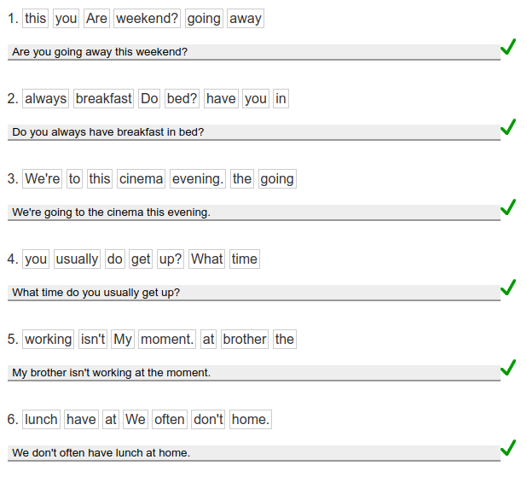

ex 6

I don't think so. Previously, women had fewer rights than men. So they didn’t work. They stayed at home and did household chores while the men were worked and earned money. But our days, woomen and men are equal. They also working like a men. So today pairs are share responsibilities and take turns cooking.